1. The mood board: Modern editorial luxury
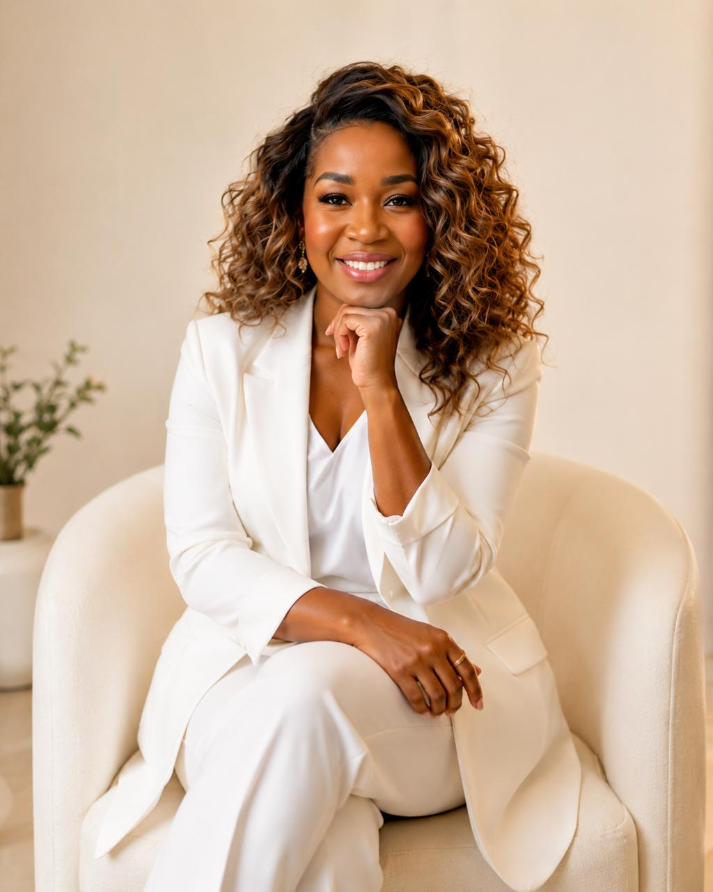
Portrait direction
Commanding, elegant, warm and confident. Photography that feels like an international editorial feature.
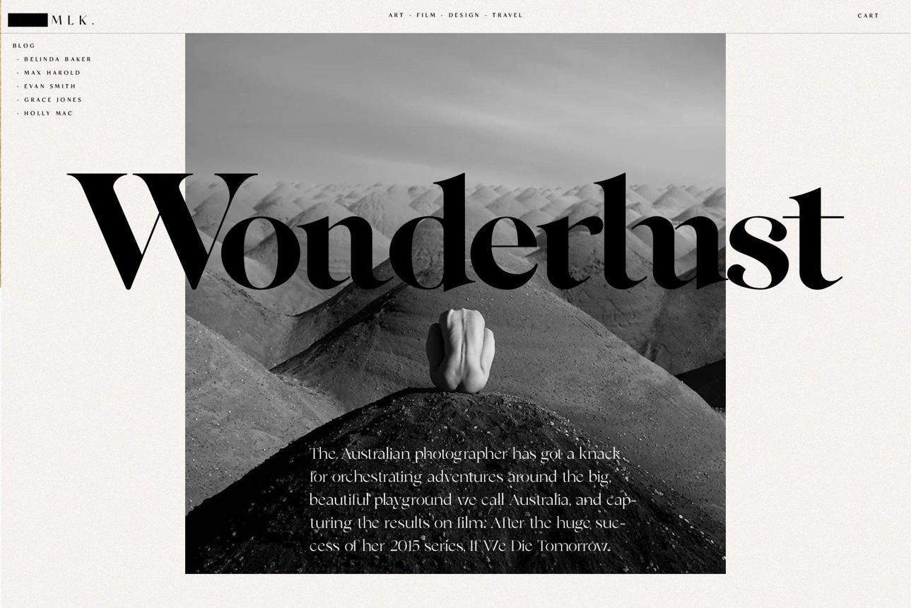
Typography and layout
Oversized editorial headlines, elegant serif typography, generous white space and restrained colour.
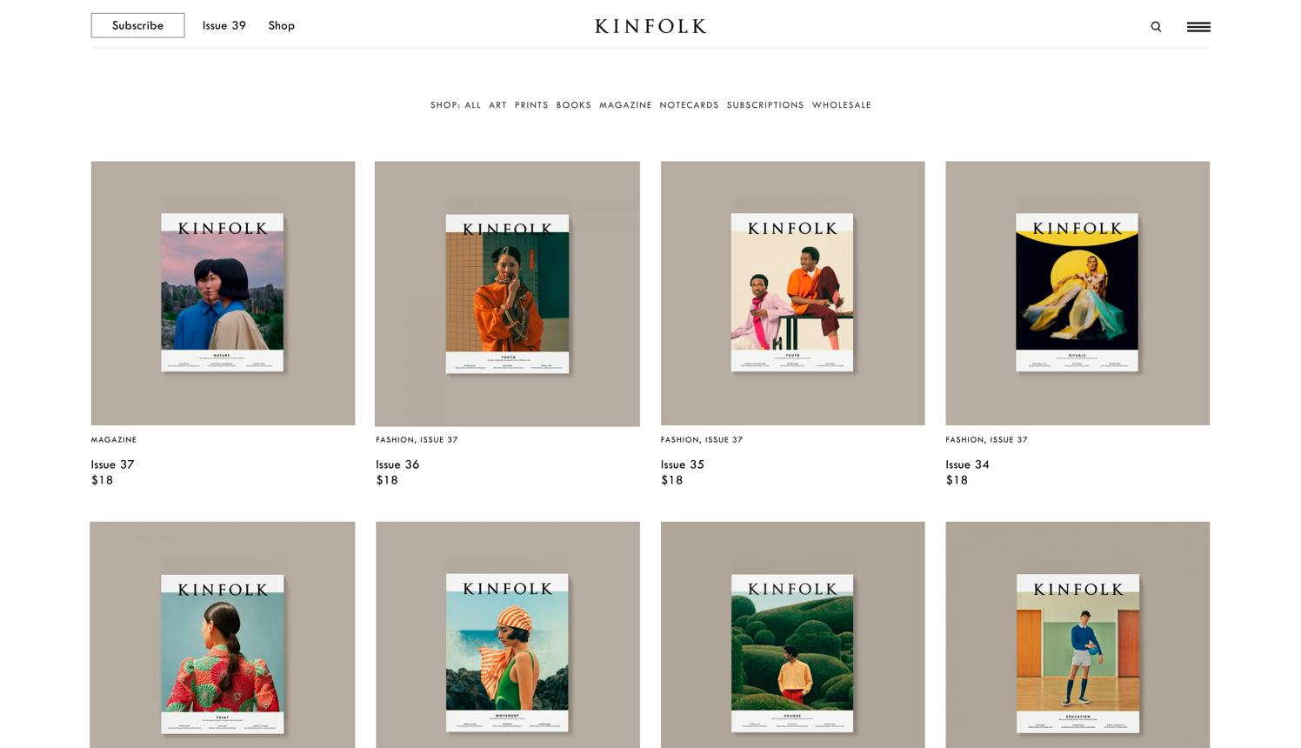
Media gallery
Clean grids displaying publication covers, interviews and features, each linking to the original article.
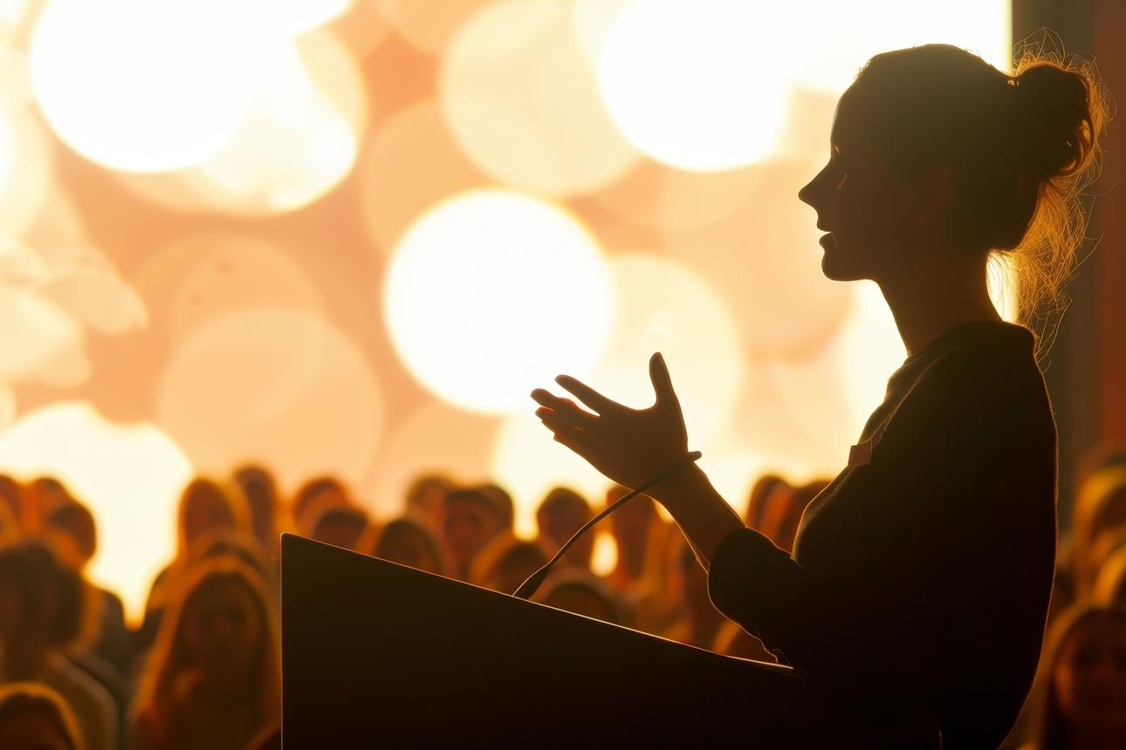
Speaking portfolio
Cinematic photography that communicates presence, credibility and the experience of being in the room.

2. The editorial features page
This is particularly important because I want your media coverage to look like a curated editorial archive, not a collection of random logos.
SAMPLE PAGE · IN THE MEDIA

Stories. Conversations. Perspectives.
A collection of features, interviews and conversations exploring the work, ideas and experiences of Naomi Osemedua.
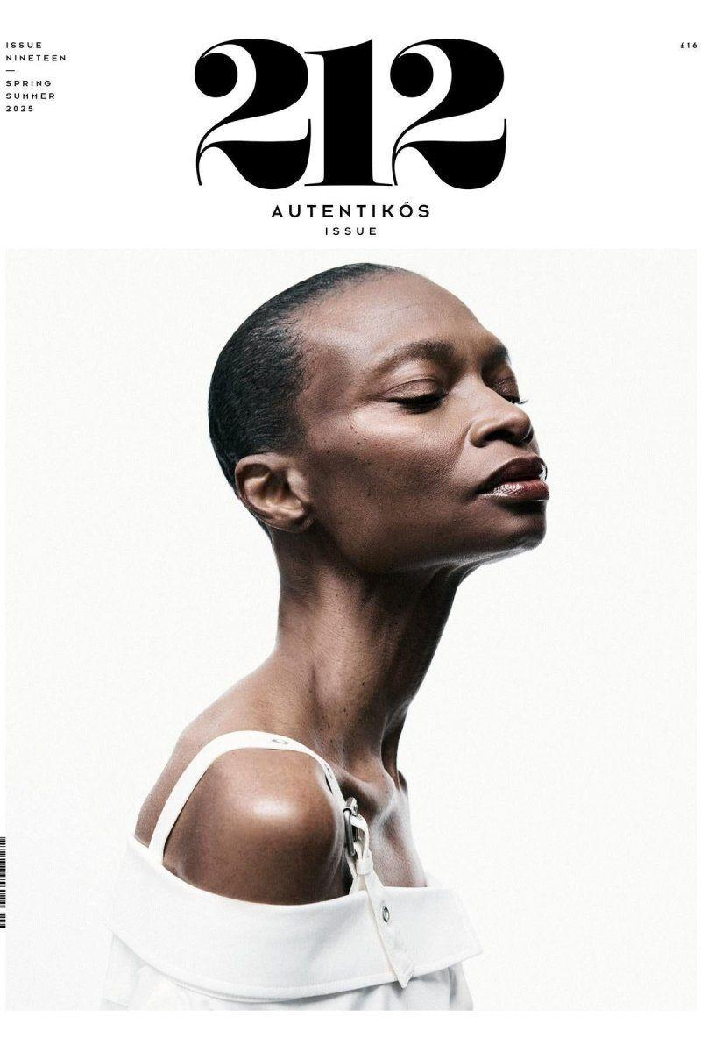
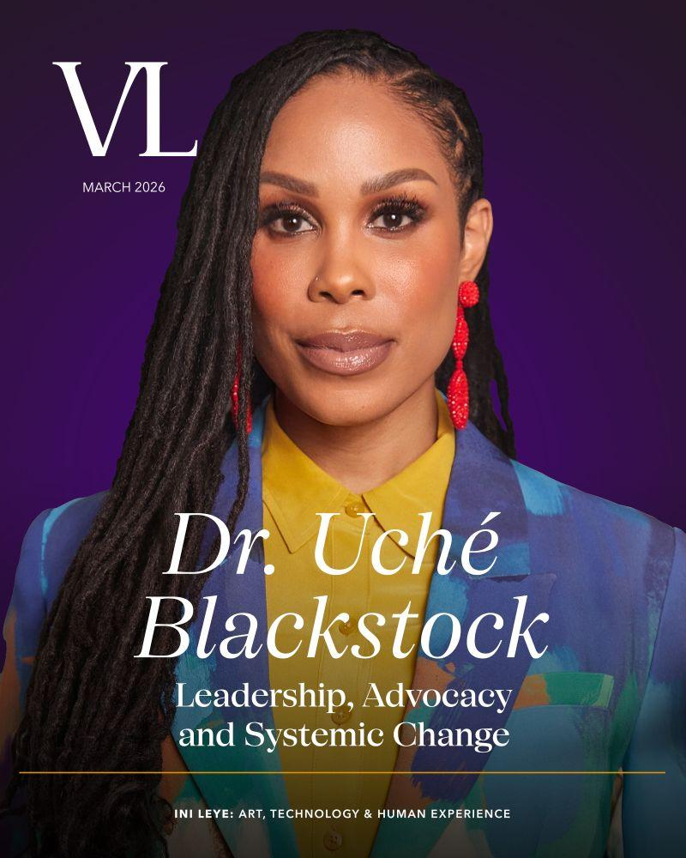
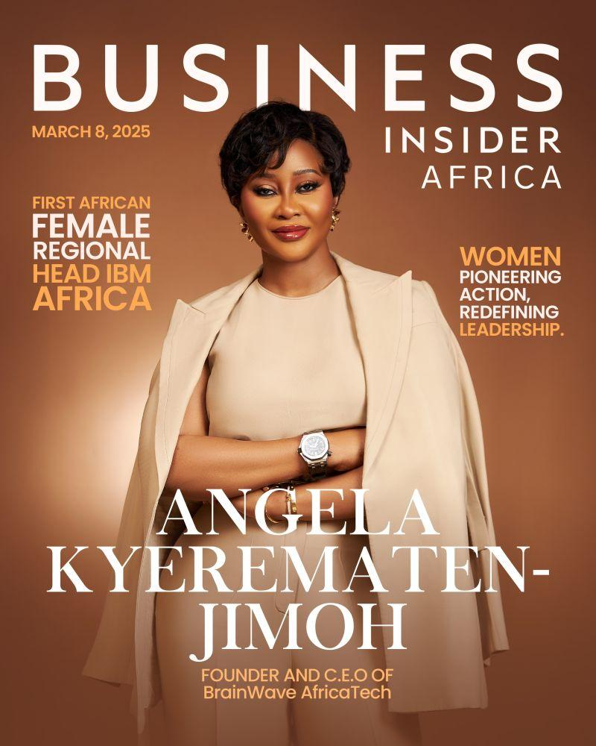
These are illustrative editorial references, not your actual published features. Your original magazine covers and article images will replace them.

3. The homepage visual direction
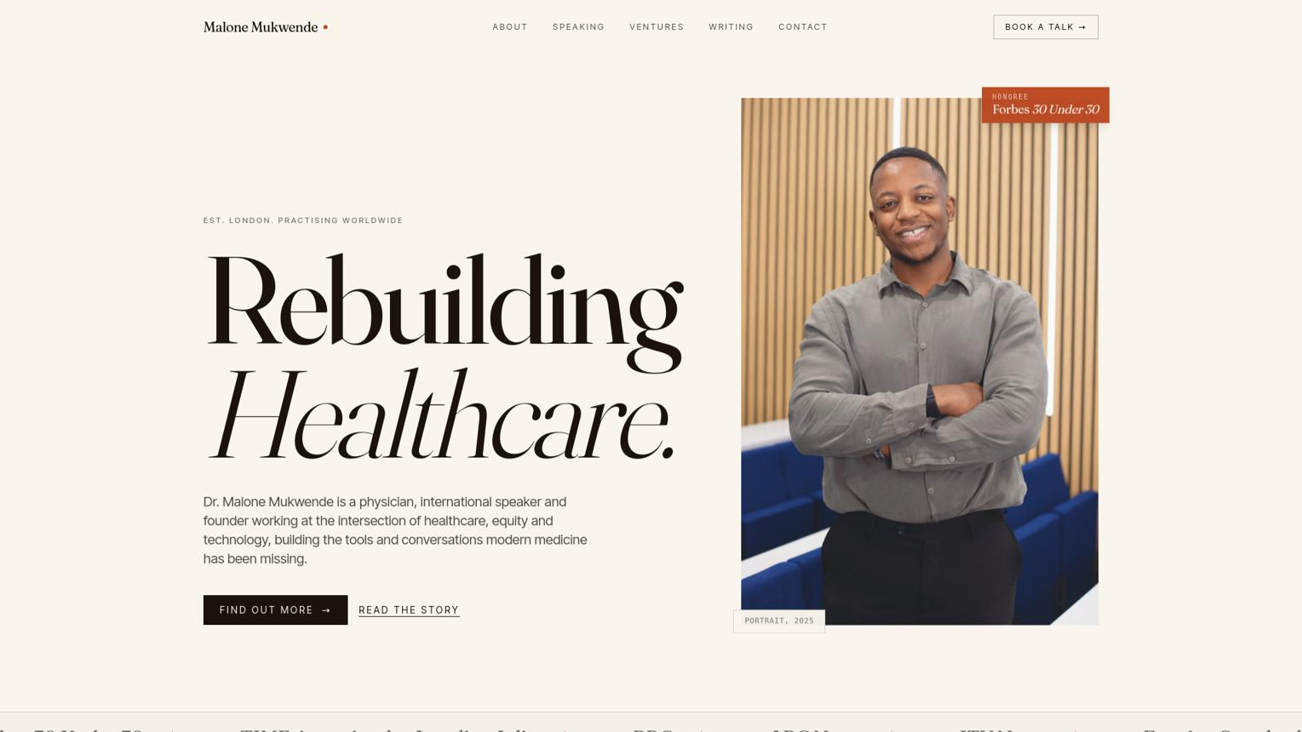
malonemukwende.com
For the homepage, I would retain the warm ivory background, charcoal text, beautiful portrait photography and sophisticated typography. Your public promise should feel integrated into the design rather than displayed like a motivational quote.
For the Work chat: You can share these visual references directly, or copy this instruction:
Use the visual references from the original Naomi HQ mood board: modern editorial luxury, warm ivory and charcoal, sophisticated serif typography, cinematic portrait photography, generous white space and a magazine-inspired media gallery. The editorial page should display actual publication covers as clickable images linking to the original articles. Keep the overall design premium, minimal, international and warm.
One important distinction: these are visual inspiration images, not finished website mockups or downloadable source assets. The webmaster should recreate the design direction using your actual photographs and verified media covers.

